unsubscribe link

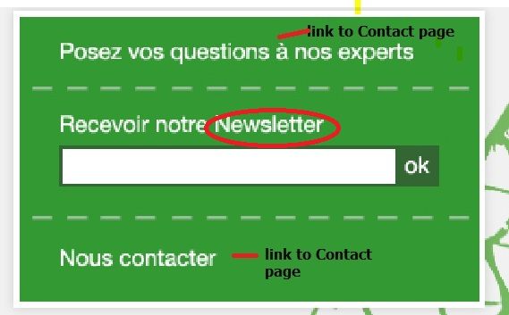

Text for Newsletter : confirmation sending/Wrong Email / Email already exist/

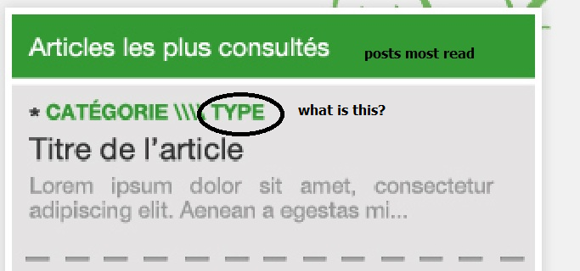

- Slider: each page different or the same?

